**User Studies**

Going In, our Testable Product was not quite complete. The biggest thing it was missing was the ‘browse’ feature, so we’ll leave out feedback like “finish the browse”. Everything else was functioning on some level. Here are the critiques and our plans to fix them/what we have already done.

1. **The Upload Box**

As far as functionality, one complaint was that if you changed your mind about uploading something, you’d still have to go through the whole process before being able to do something else (without refreshing the page).

Also, the standard form buttons were ugly.

So, we added an ‘x’ button at the top. It allows the user to ‘cancel’ the request to upload. We also made the buttons match our site, and included only one. The upload is automatic after the image selection

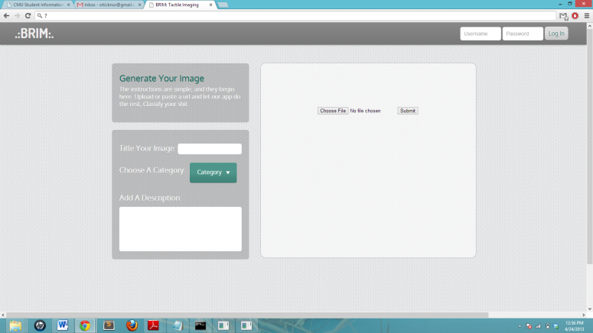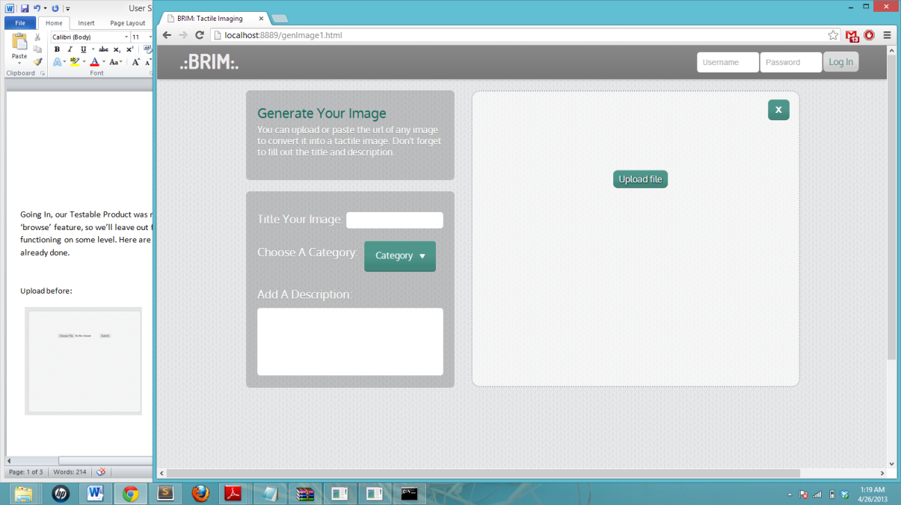 Upload before: Upload after:

1. **The Convert Button**

The convert button was displaying all the time underneath the upload box, whether there was an image there or not. This led to some confusion and users were ending up trying to convert an image that wasn’t there. So we took it out and now only include it when an image is uploaded and ready to convert (seen above).

1. **Log In Issues**

We noticed that there were some bugs with our log in and with two users on the server, their images were overwriting eachother. We fixed this by using session storage for images that are being worked with. This has seemed to work great, we are not running into the same problems.

We also need to add a register button/screen. It is not clear that you can register a name and password by just typing in your intended name/pw and submitting. We have not implemented this yet but we have decided that the register button will take the user to a separate screen with the commonly seen registration dialog box.

1. “**Want to see converted braille, not the .txt”**

Before, the user would see the .txt file meant to be sent to a braille printer. It would give a general idea of what the image might look like, but a lot was left up to the users imagination. Now, we have imported a braille font and use fs.readfile to convert the text file into the braille that it would print out.

When logged in, a save button appears next to the new image. This will save the image to the current user’s profile.

We have plans to include the other filters, which are already written in python. We just need to include a user interface for toggling between them.

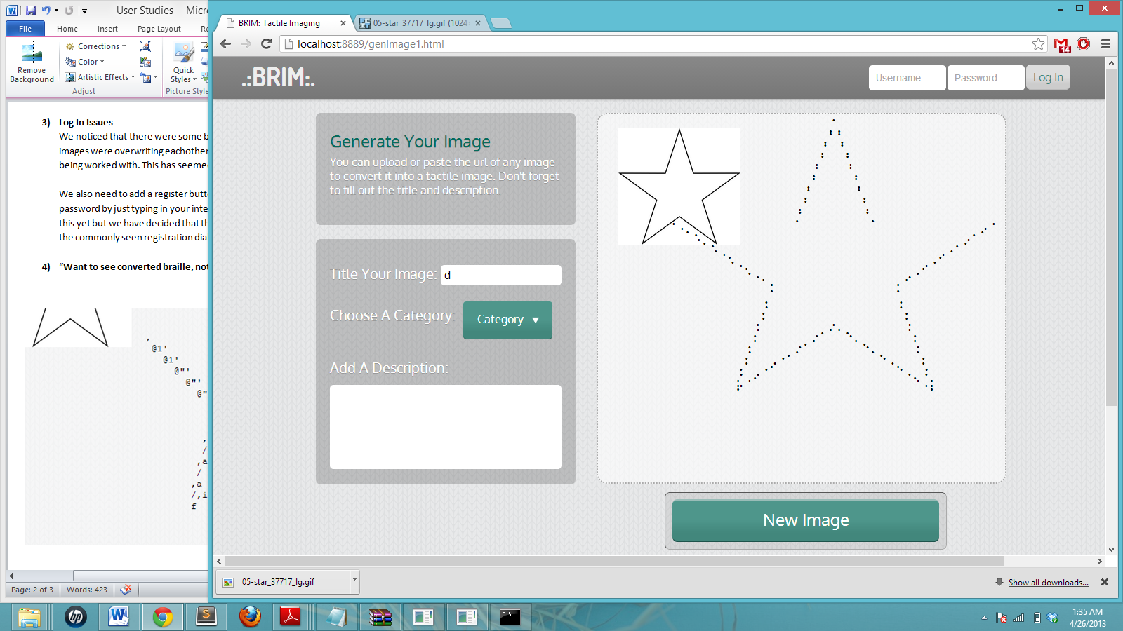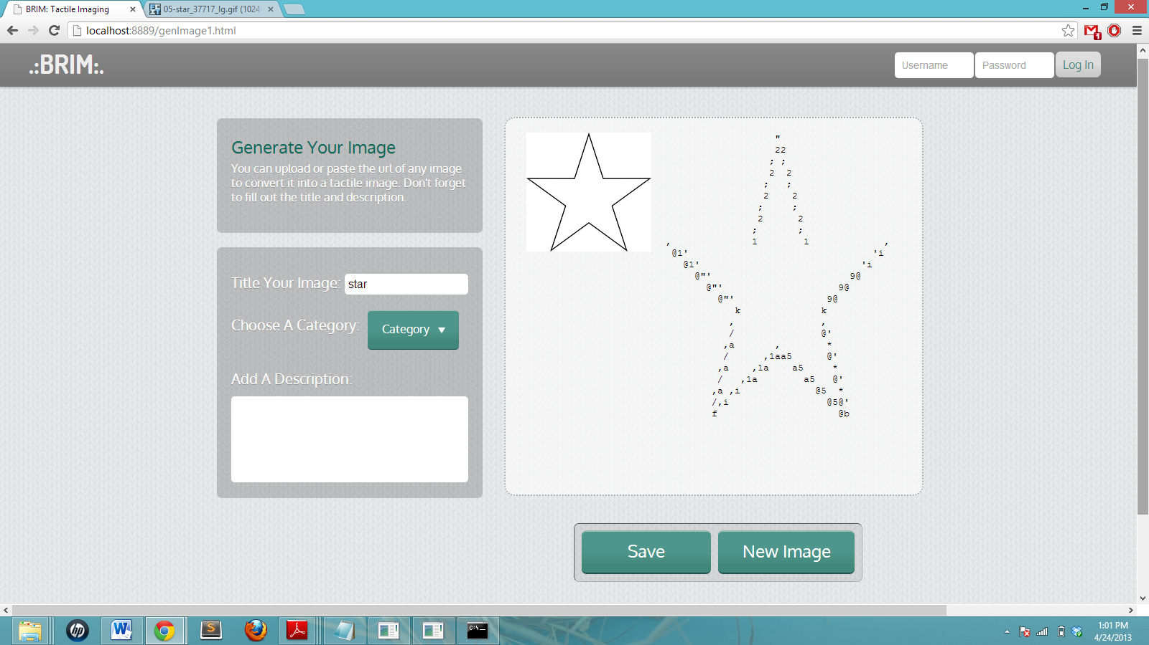 Before: After!:

1. **Small Fixes**
2. Home Screen about us, smaller and lower because less important
3. Option to ‘save’ image to user library vs download text file to print (make the difference clear)
4. Adapt to changes in screen size (mobile, tablet)
5. Buttons in category menu, hard to click, only text is clickable, fix this

**User Studies Part Two**

Sweep two of fixes based on user studies. These changes included creating the entire mobile version, implementing the browse feature, and many others!

1. **More Login Changes**

Originally, the login doubled as a ‘register’ button. If the user name was not registered, it would automatically create the account. This led to confusion, “how to register??” and “what happens if I type in the wrong username?? New account??”

We created the new login feature so that the top-right menu in the corner of each page pulls out a login/register drawer. Now, the login and register pages are separate. When logged in, the face icon is replaced by the logout button.

Login before:

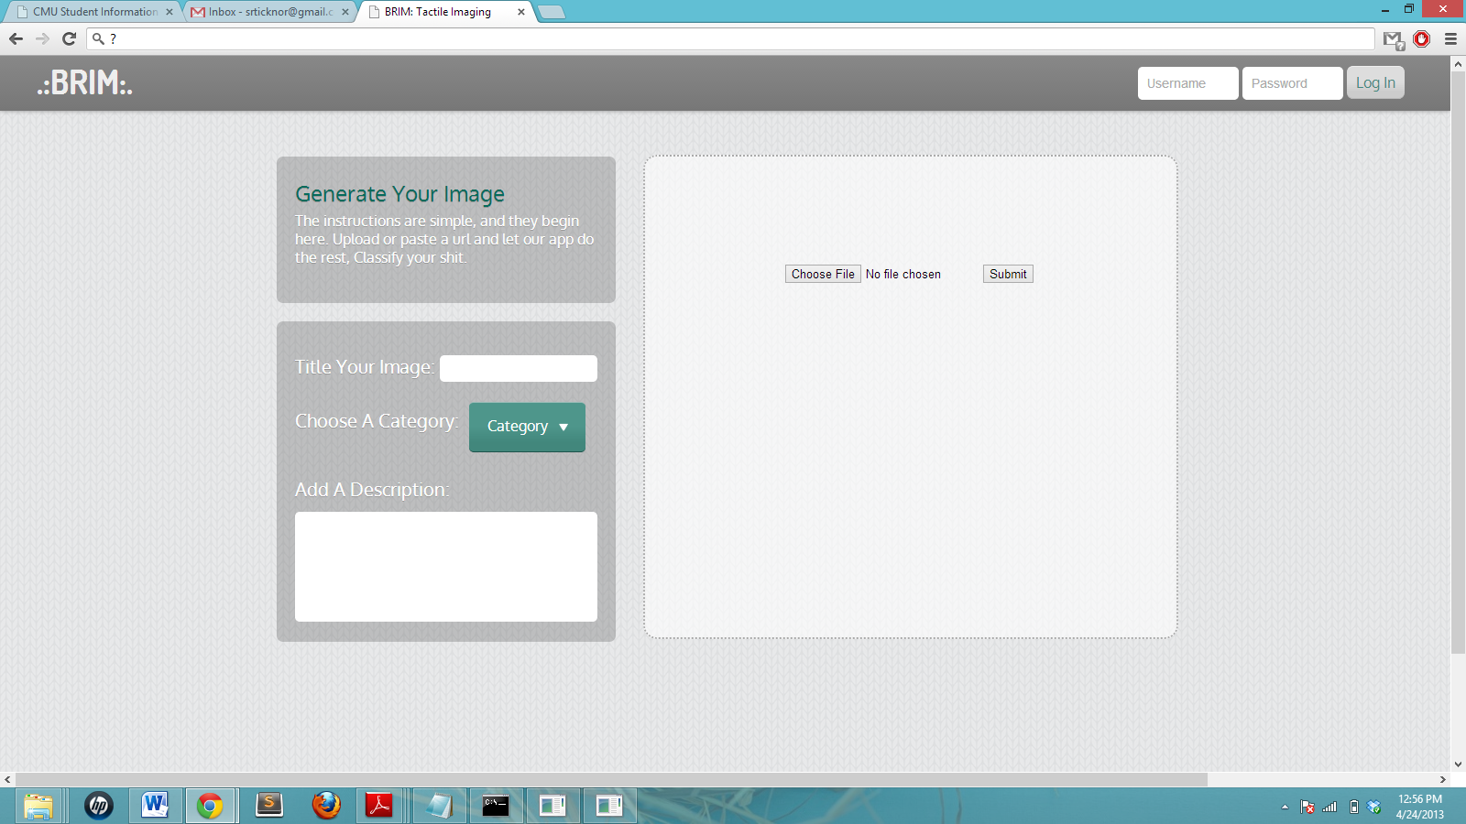

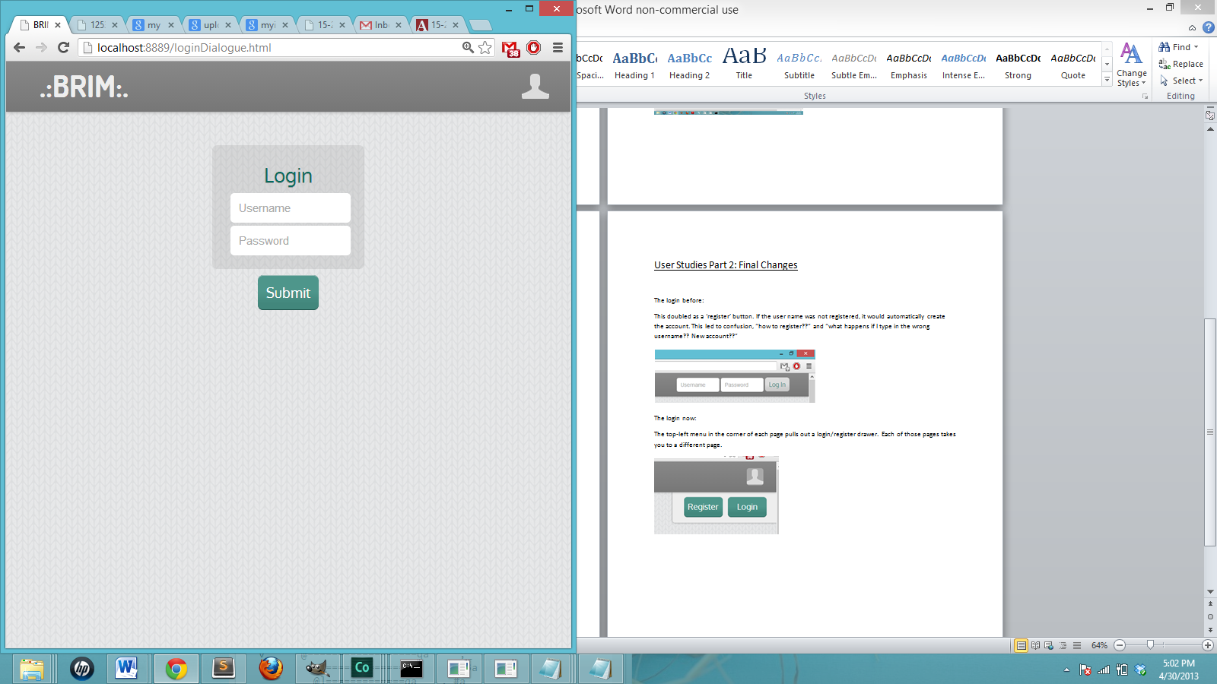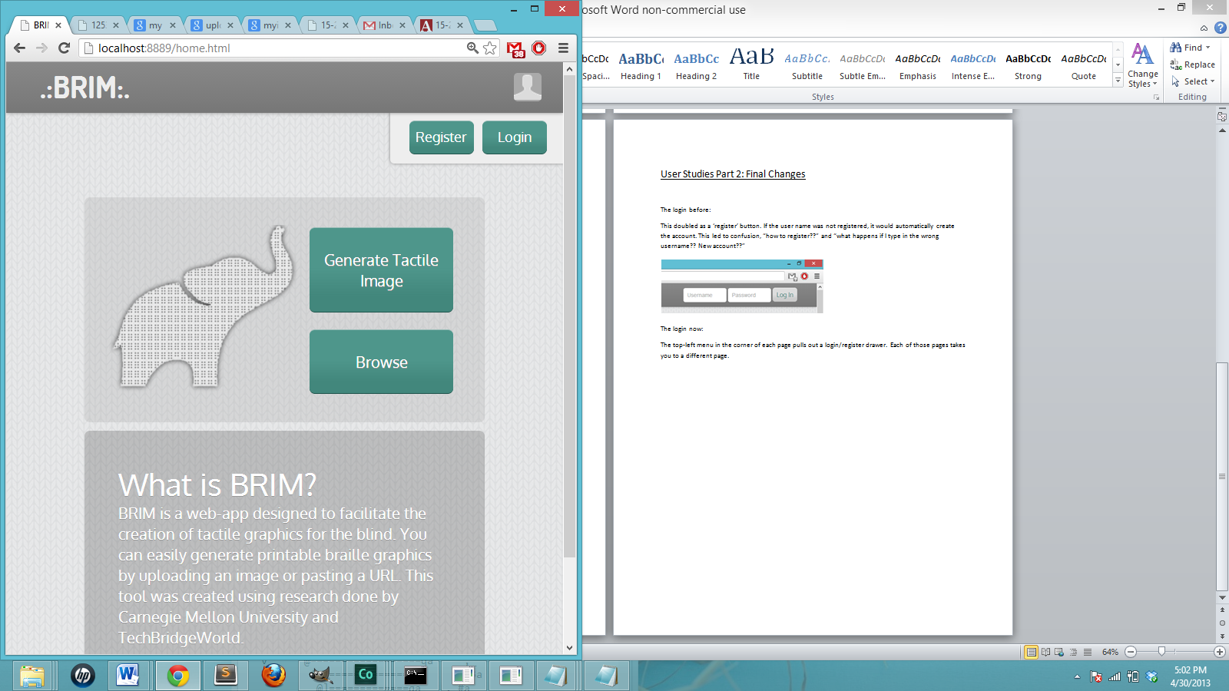 Login after:

1. **Home Screen**

The normal home screen is on the left and the logged in home screen is on the right. There were critiques of too much text distracting from the important parts of the page. Also, the design was very static, and not optimized for all screen sizes, especially not mobile.

Home Screen Before:

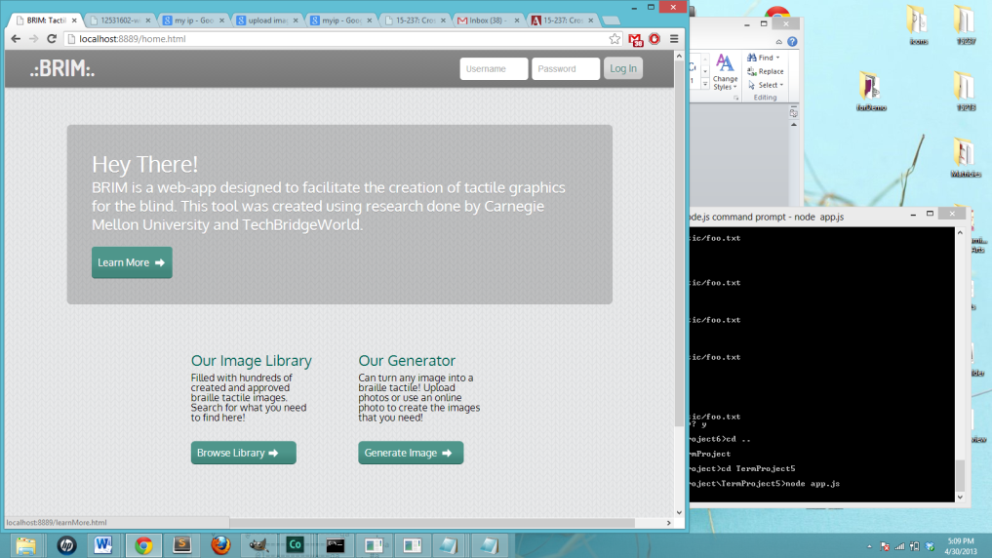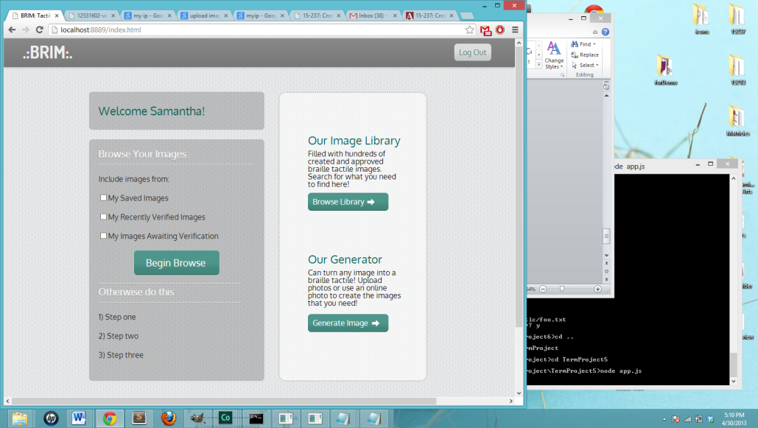

The logged in home screen and mobile home screens are shown below. We simplified the design a lot and removed a lot of unnecessary text. We added an elephant graphic to give an example of what we mean by ‘tactile image’. The pages are now also dynamic, making it optimized on every screen, including a version specifically designed on for mobile platforms.

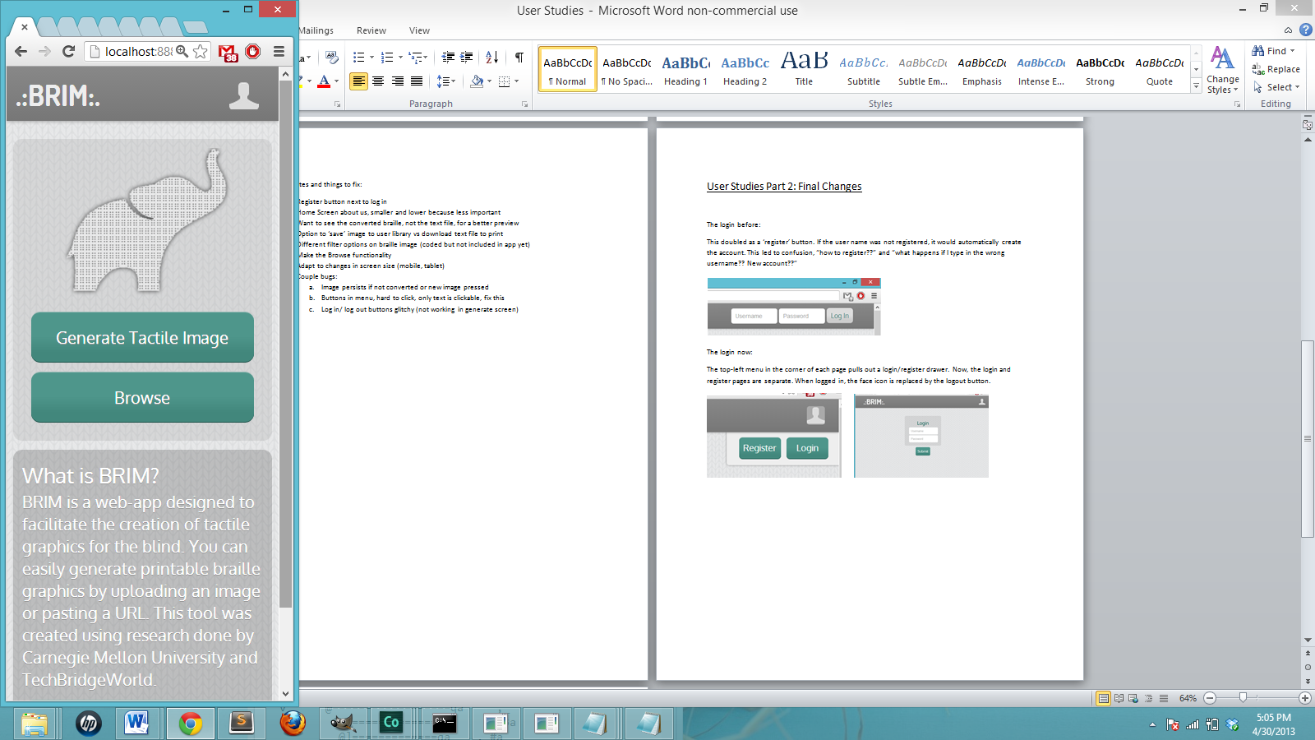Home Screen After:

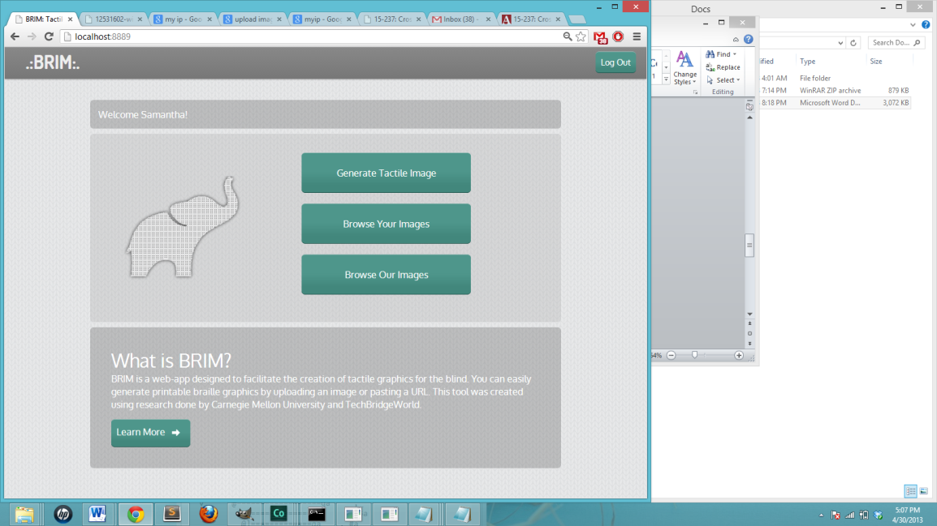

1. **Adding Different Filters**

When conducting the user studies, we only had 1 filter available. This worked well for a certain type of images but not so well for others. We included 2 more filters, which each use a different algorithm for generating the binary image. This allows our application to produce accurate braille for most images.

Before using one standard filter:

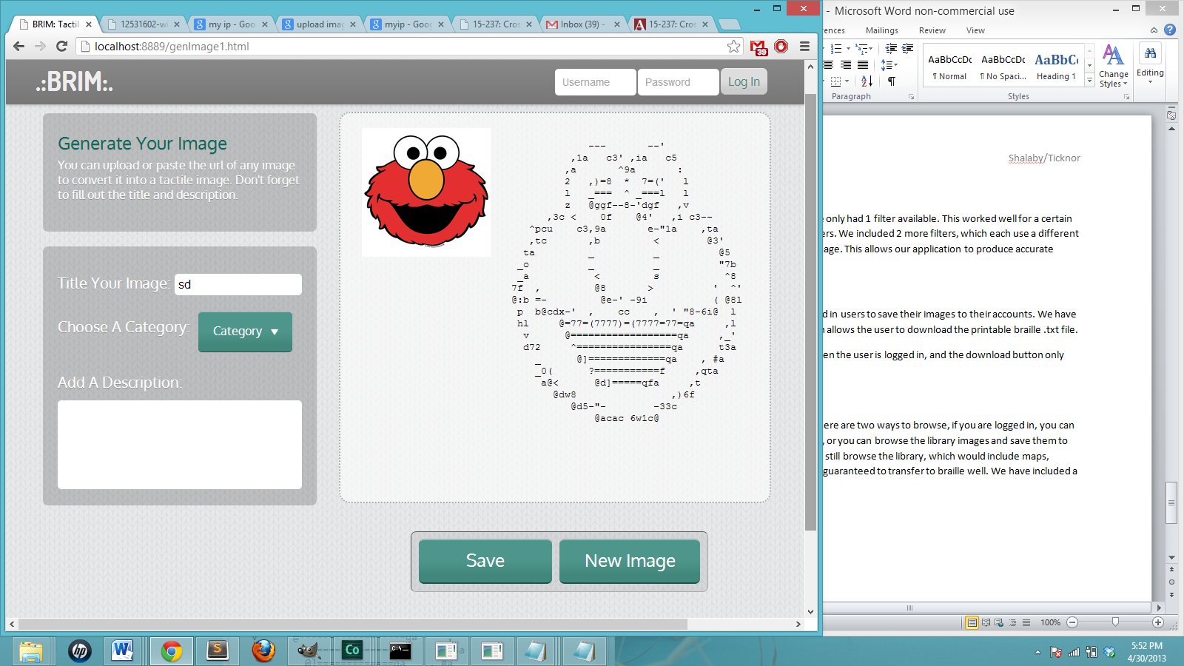

Example of different filters:

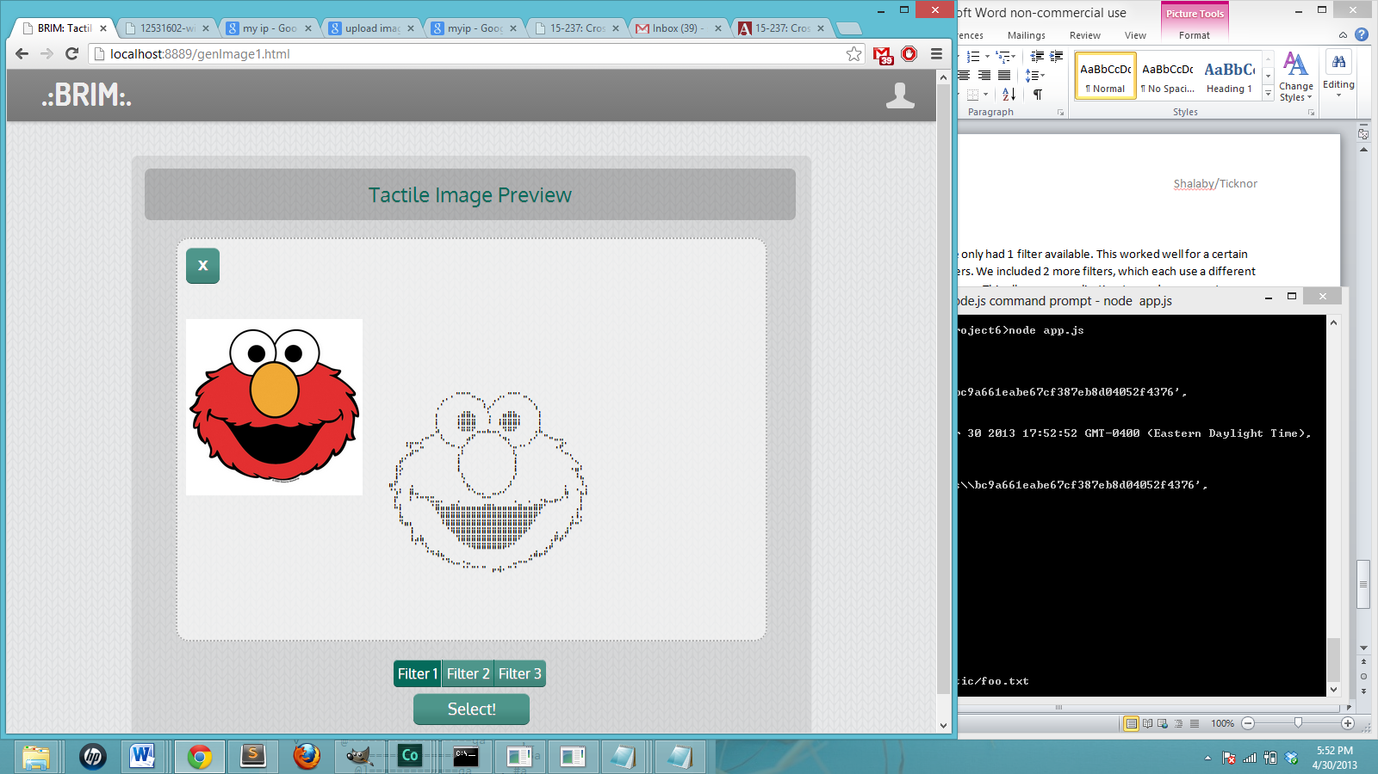 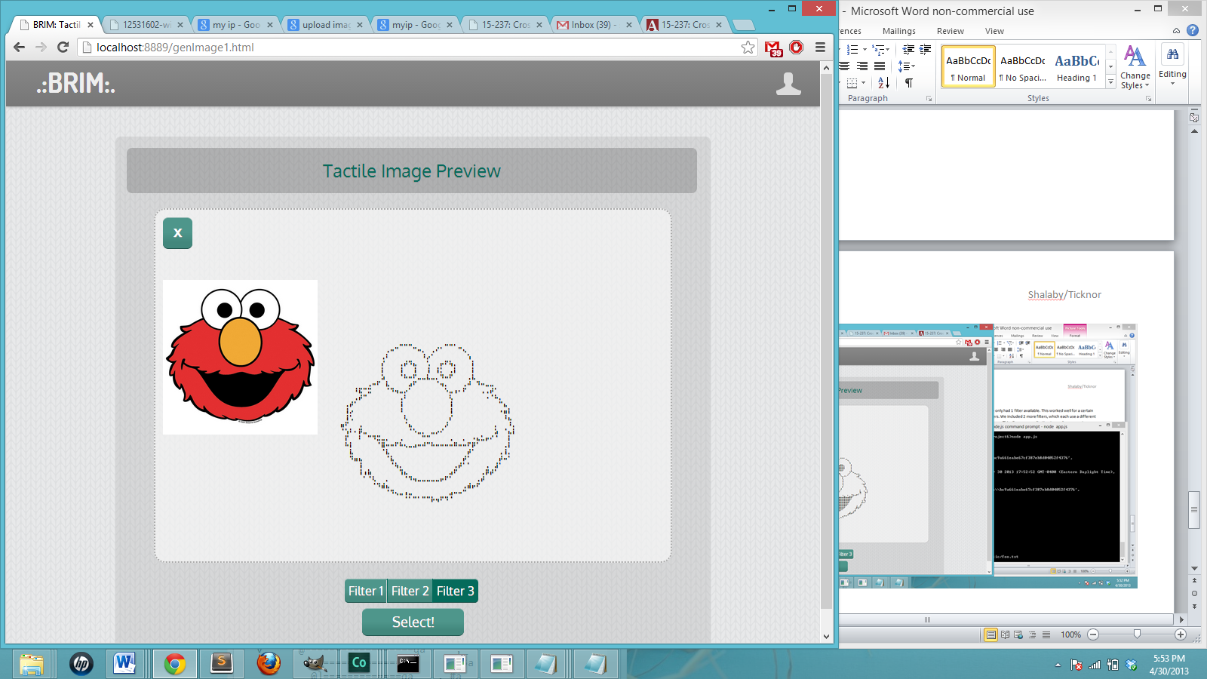

1. **Save vs Download**

Previously, our app had allowed logged in users to save their images to their accounts. We have now added a download feature, which allows the user to download the printable braille .txt file.

Also, the save button only appears when the user is logged in, and the download button only appears on the desktop version.

Save and Download separated: The downloaded text file:

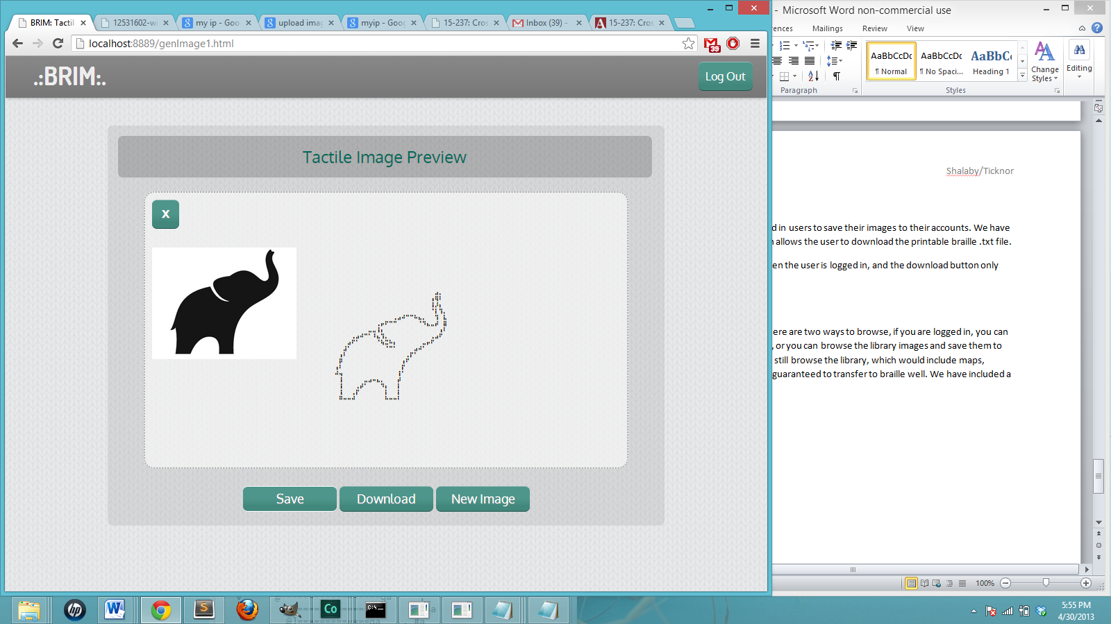 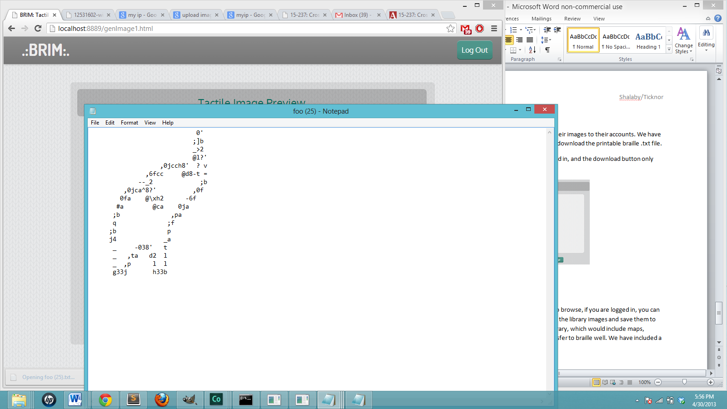

1. **Browse Feature**

We added a browse feature finally! There are two ways to browse, if you are logged in, you can browse all the images you have saved, or you can browse the library images and save them to your account. If not logged in, you can still browse the library, which would include maps, shapes, letters, and diagrams that are guaranteed to transfer to braille well. We have included a small sample library.

